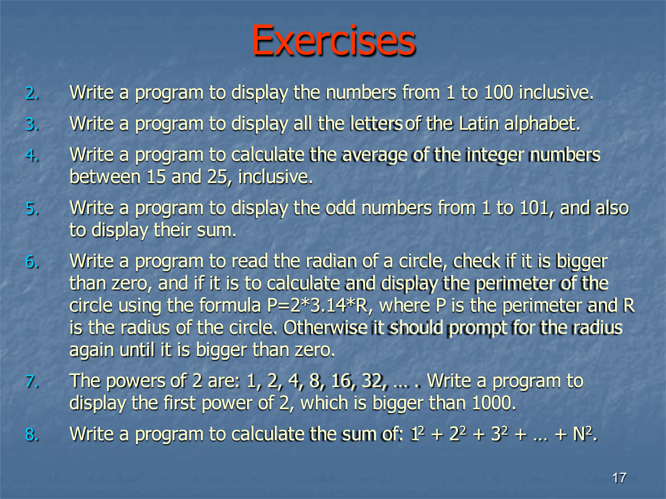

1. Write a code in cpp to find the reverse of an entered number.
2. Write a cpp code to check if entered number is palindrome or not.
3. Write a cpp code to check a number is Armstrong or not.